

WORK BREAKDOWN STRUCTURE (WBS)

Date | 11-07-2026
Team ID
Project Name | OptiCrop: Smart Agricultural Production Optimization Engine

WBS Diagram

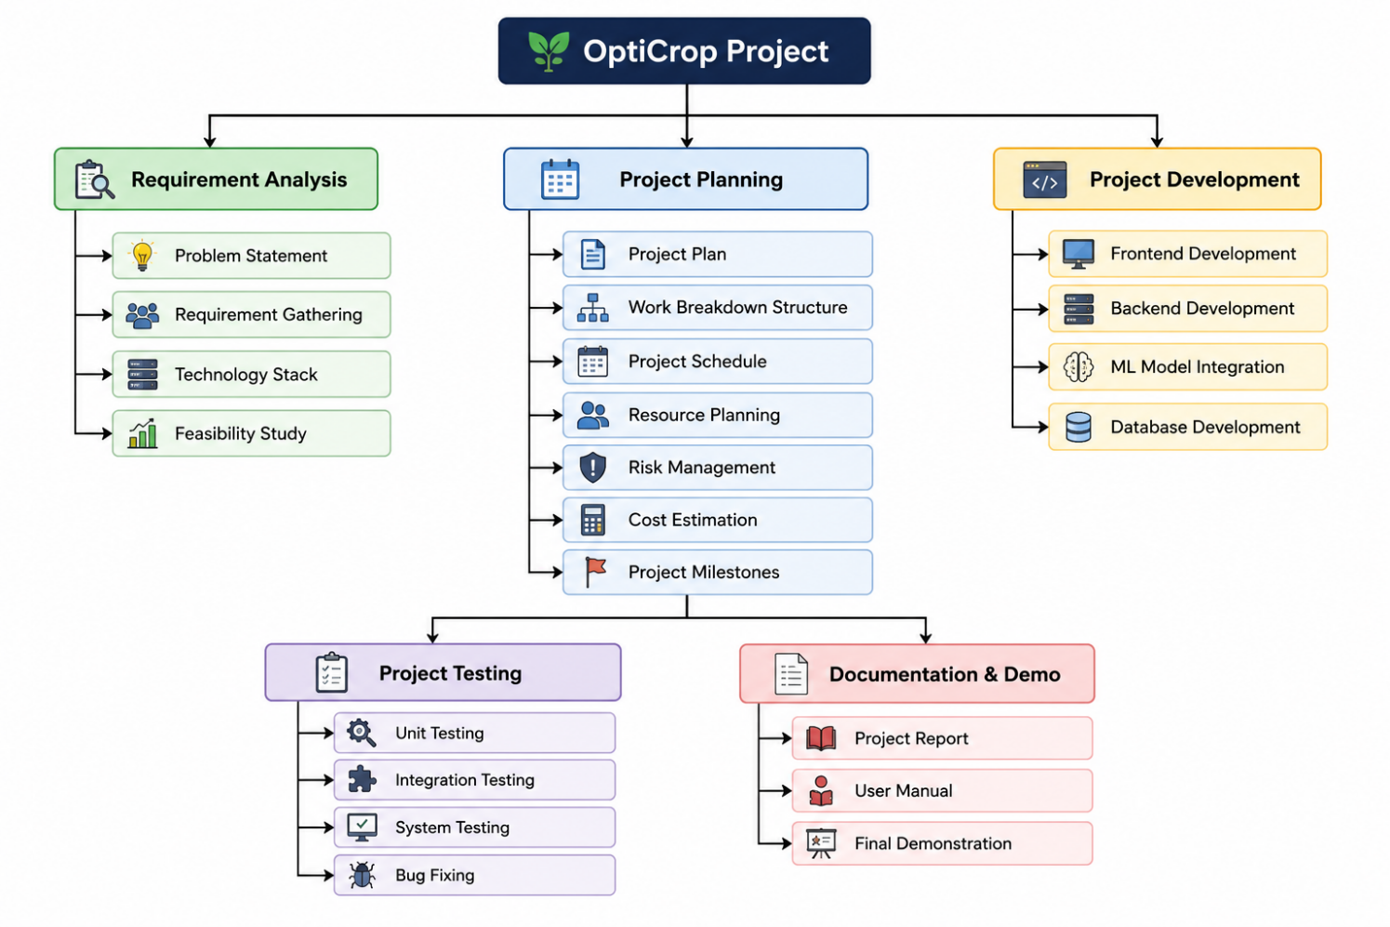

WBS Table
Objective | Responsibility
1.0 | Requirement Analysis
2.0 | Design
3.0 | Planning
4.0 | Frontend Development
5.0 | Backend Development
6.0 | ML Integration
7.0 | Testing
8.0 | Documentation
9.0 | Demonstration

